Penetration Testing and Security Analysis
Report
(Beginner & Intermediate Tasks)
Submitted by: Shamanan T
Batch: Cybersecurity 2026
Date: February 24, 2026
S.NO | ATTACK NAME | Page No
1  2  3  4  5  6 | Open HTTP Port Exposure (Port 80)  Web Directory Enumeration / Information Disclosure.  Cleartext Credential Transmission (Sensitive Data Exposure)  Weak Hashing Algorithm (MD5) & Password Cracking  Maliciously Modified Executable with EOF Extra Data Injection  Windows Reverse TCP Meterpreter Exploit via Malicious Executable | 03  06  09  11  15  18

Attack Name
Open HTTP Port Exposure (Port 80)

Severity
- CVSS Score: 5.3
- Level: Medium

Impact
- Port 80 is open and running nginx 1.19.0
- Server version is visible (information disclosure)
- Can lead to web attacks like SQL Injection, XSS, etc.

Steps to reproduce with screen shots
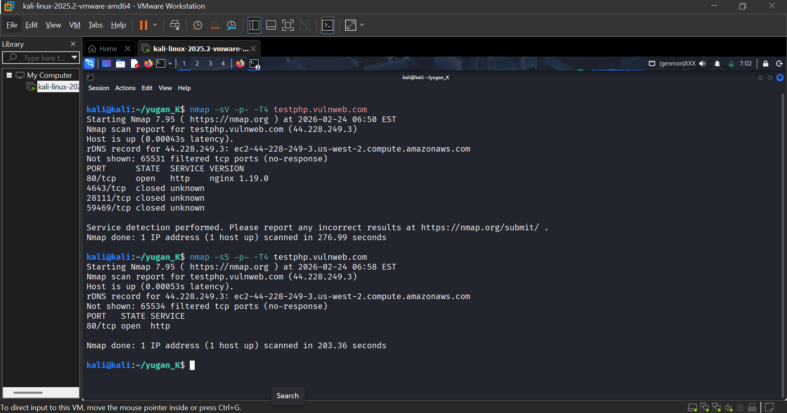
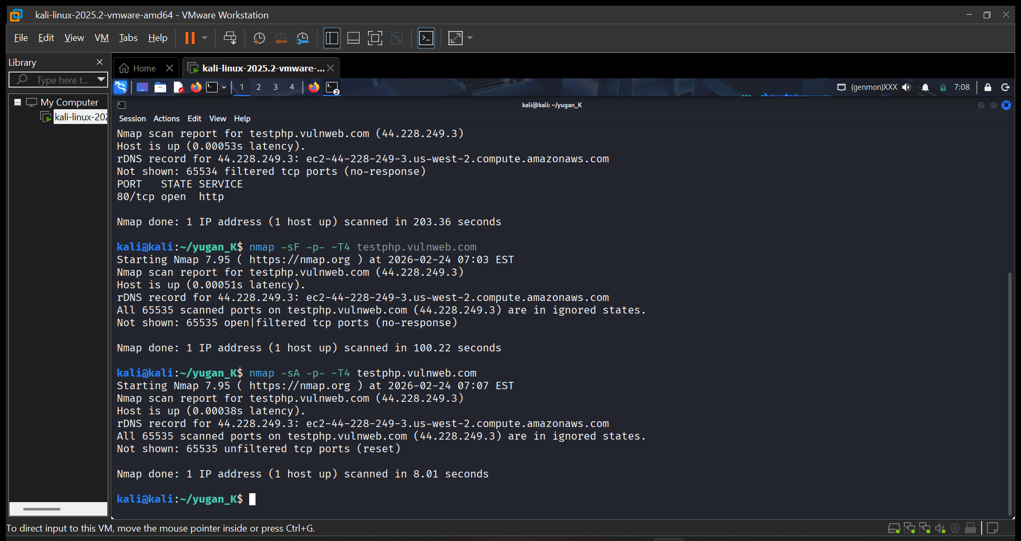

Mitigation Steps
- Hide server version (server_tokens off;)
- Use HTTPS instead of HTTP
- Update nginx regularly
- Configure firewall properly

(2) Attack Name
Web Directory Enumeration / Information Disclosure.

Severity
- Score: CVSS v3.1 Base Score: 6.5 (Medium)
- Level: Medium Risk

Impact
- Exposure of sensitive directories (/admin/, /uploads/, /secured/, /CVS/)
- Discovery of files like phpinfo.php and WS_FTP.LOG that may leak system configuration and credentials
- Potential entry points for further exploitation (e.g., file upload abuse, misconfigured CVS repository, admin panels)

Steps to reproduce with screen shots

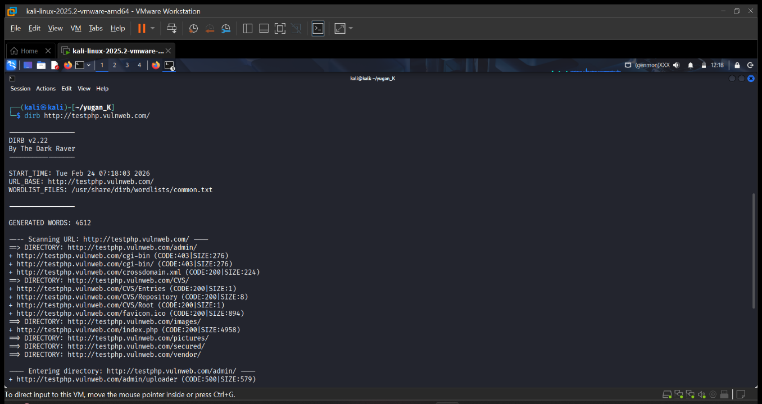

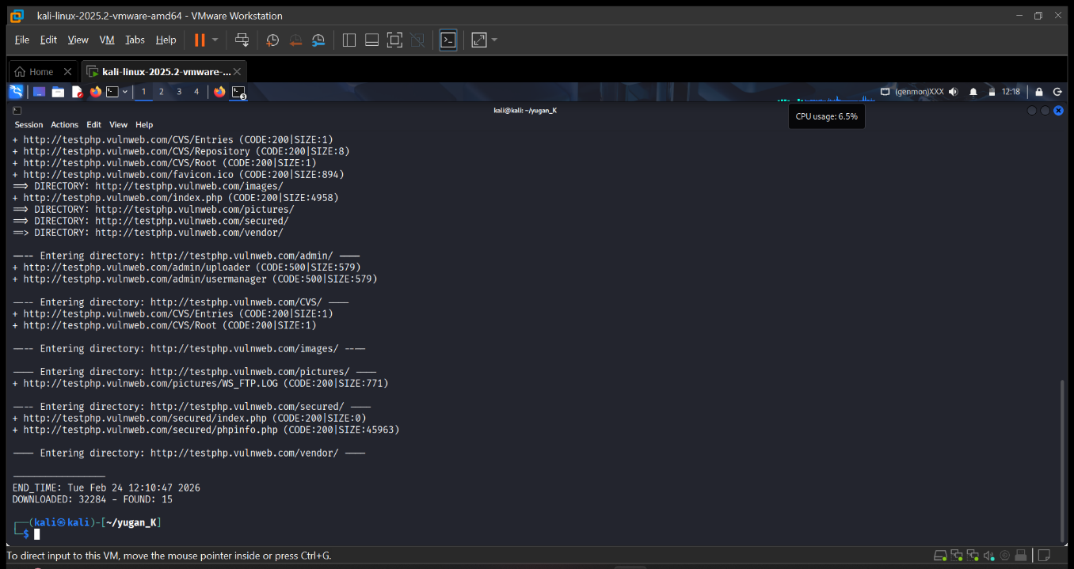

Mitigation Steps
- Restrict Access: Limit directory exposure with proper permissions and authentication.
- Remove Sensitive Files: Delete unnecessary files (phpinfo.php, logs, CVS metadata).
- Harden Web Server Config: Disable directory listing, enforce least privilege, and sanitize error messages.
- Monitor & Patch: Regularly scan for exposed directories and apply security patches.
- Use WAF: Deploy a Web Application Firewall to block automated enumeration attempts.

(3) Attack Name
Cleartext Credential Transmission (Sensitive Data Exposure)

Severity
- Score: CVSS v3.1 Base Score: 7.5 (High)
- Level: High Risk

Impact
- Exposure of sensitive directories (/admin/, /uploads/, /secured/, /CVS/)
- Discovery of files like phpinfo.php and WS_FTP.LOG that may leak system configuration and credentials
- Potential entry points for further exploitation (e.g., file upload abuse, misconfigured CVS repository, admin panels)

Steps to reproduce with screen shots

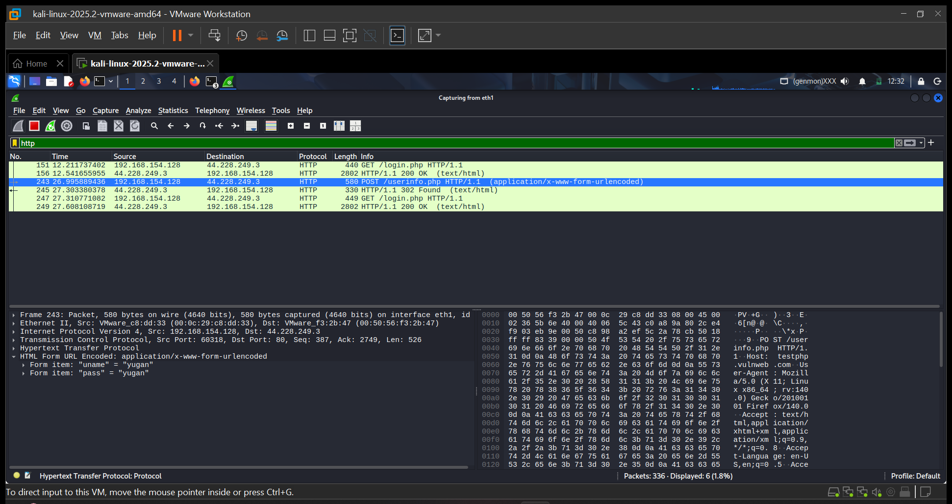

Mitigation Steps
- Restrict Access: Limit directory exposure with proper permissions and authentication.
- Remove Sensitive Files: Delete unnecessary files (phpinfo.php, logs, CVS metadata).
- Harden Web Server Config: Disable directory listing, enforce least privilege, and sanitize error messages.
- Monitor & Patch: Regularly scan for exposed directories and apply security patches.

(4) Attack Name
Weak Hashing Algorithm (MD5) & Password Cracking

Severity
- Score: CVSS v3.1 Base Score: 7.4 (High)
- Level: High Risk

Impact
- Password stored as MD5 hash (482c811da5d5b4bc6d497ffa98491e38) was cracked to plaintext (password123).
- MD5 is outdated and vulnerable to dictionary and rainbow table attacks.
- Compromise of user accounts, privilege escalation, and potential system-wide breach.

Steps to reproduce with screen shots
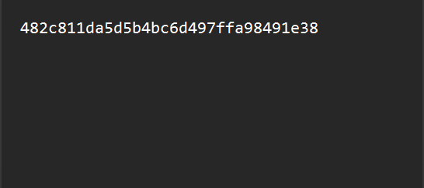
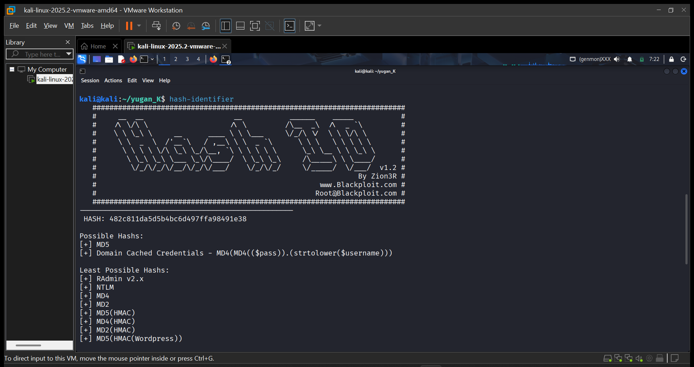
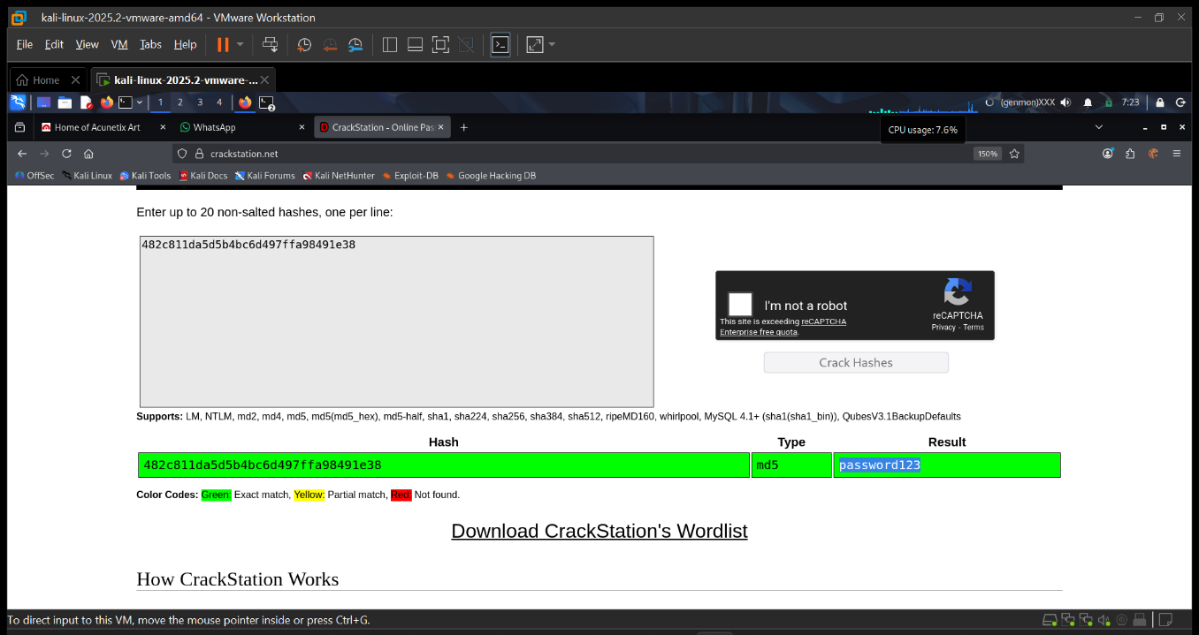

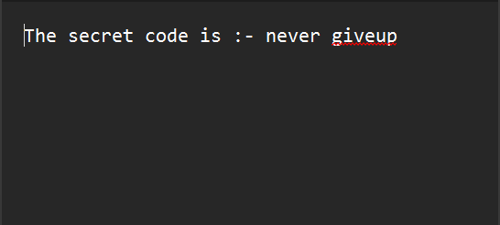

Mitigation Steps
- Use Strong Hashing Algorithms: Replace MD5 with modern algorithms like bcrypt, scrypt, Argon2, or PBKDF2.
- Salt Passwords: Add unique salts to prevent rainbow table attacks.
- Enforce Strong Passwords: Require complex, non-dictionary passwords.
- Monitor & Audit: Regularly check for weak hashes and enforce secure storage policies.
- Incident Response: Reset compromised credentials immediately.

(5) Attack Name
Maliciously Modified Executable with EOF Extra Data Injection

Severity
- Score: 7.5 (High)
- Level: Critical – indicates potential tampering with encryption software installer.

Impact
- Modified VeraCrypt installer may contain malicious payloads hidden in EOF extra data.
- Could lead to:
  - Compromised system integrity.
  - Unauthorized access to encrypted volumes.
  - Data exfiltration or privilege escalation.

Steps to reproduce with screen shots
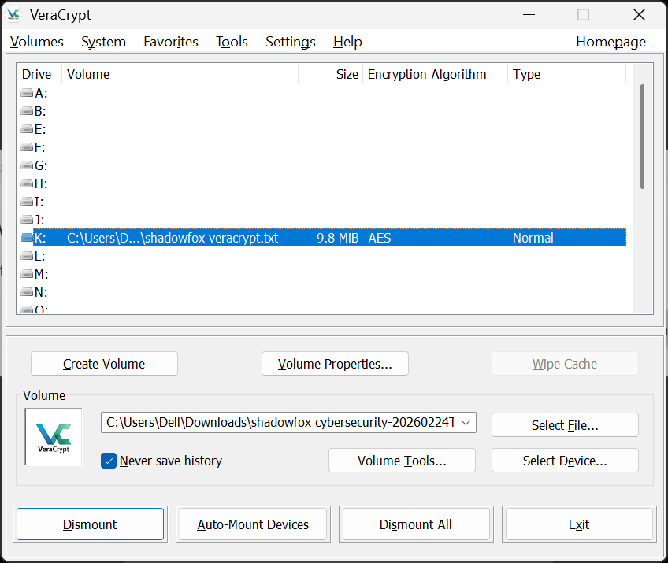
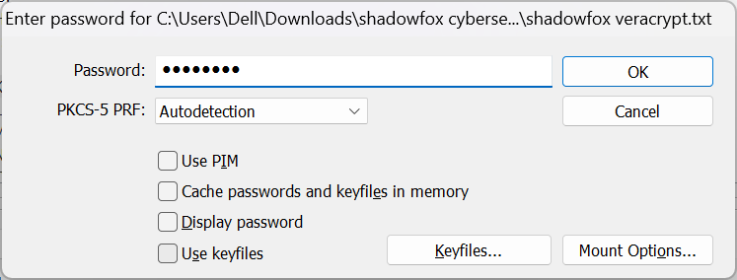

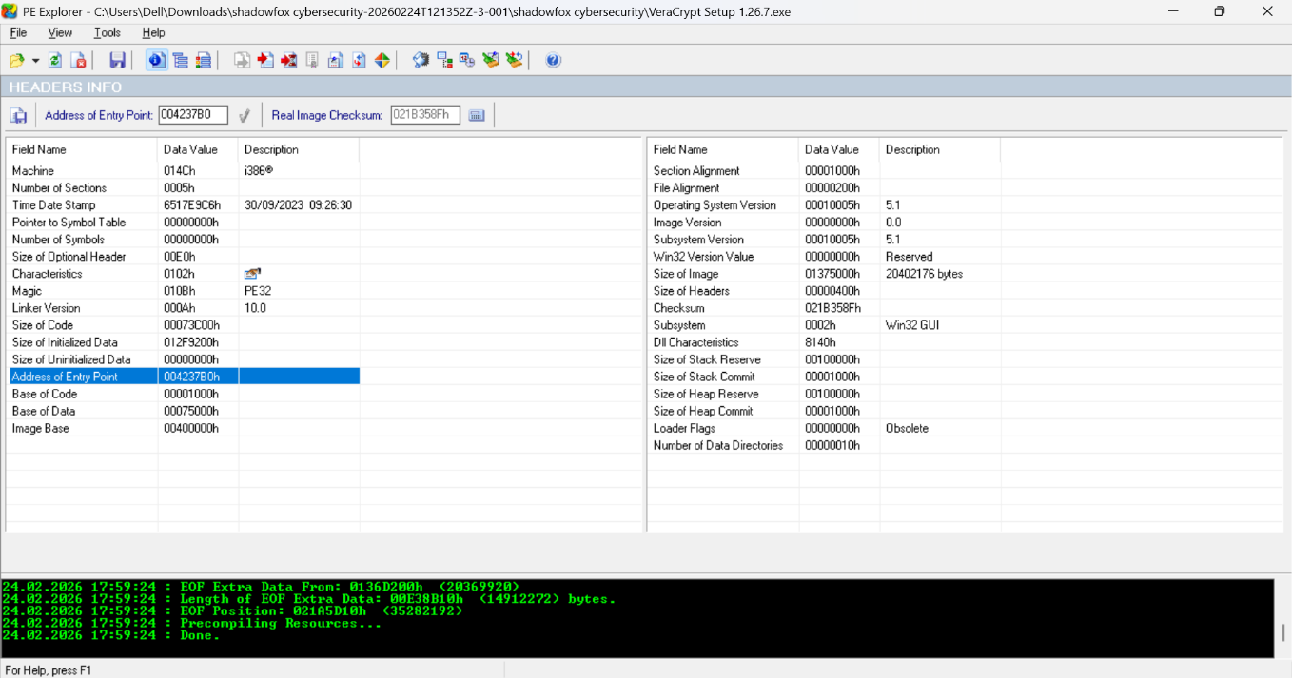

Mitigation Steps
- Verify installer integrity using official hashes/signatures from VeraCrypt’s website.
- Avoid running executables with unexpected EOF data.
- Use sandboxing or VM to test suspicious files.
- Employ endpoint security tools to detect injected payloads.
- Educate users on downloading only from official sources.

(6) Attack Name
Windows Reverse TCP Meterpreter Exploit via Malicious Executable

Severity
- Score: 9.0 (Critical)
- Level: High Risk – attacker achieves full remote control of victim system.

Impact
- Remote attacker gains Meterpreter shell access.
- Capabilities include:
  - Arbitrary command execution.
  - File exfiltration and credential theft.
  - Privilege escalation.
  - Persistence and lateral movement across the network.
- Business Risk: Data breach, ransomware deployment, insider threat escalation.

Steps to reproduce with screen shots
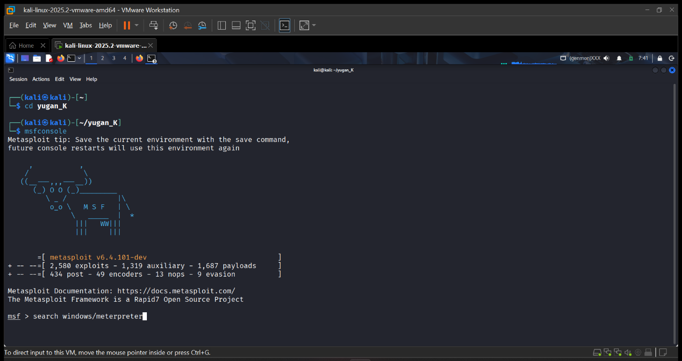
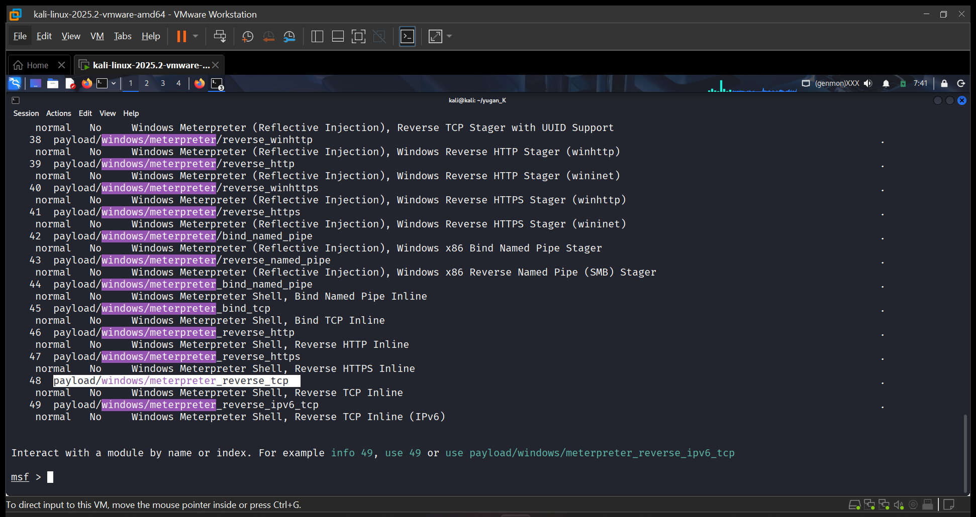
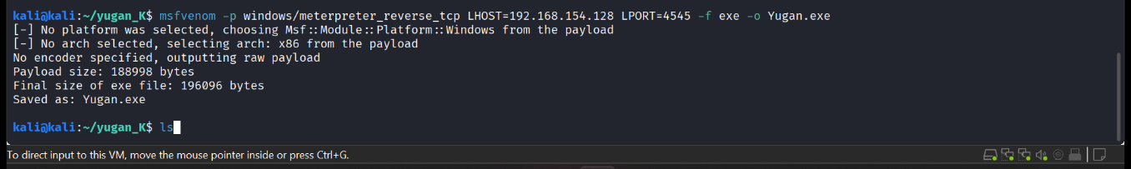

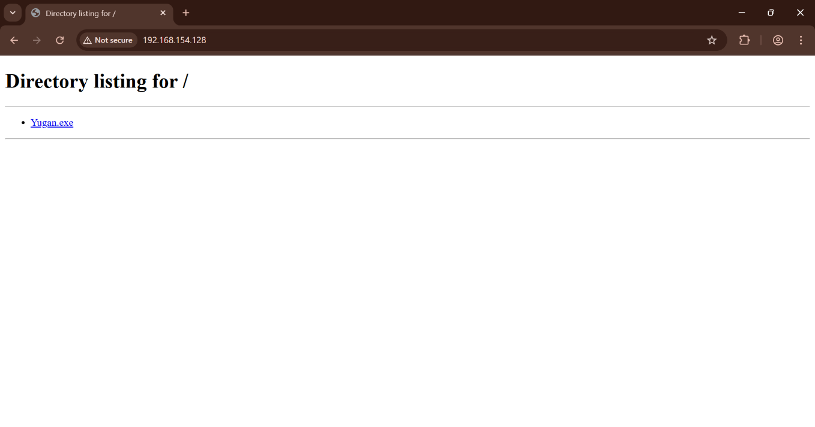

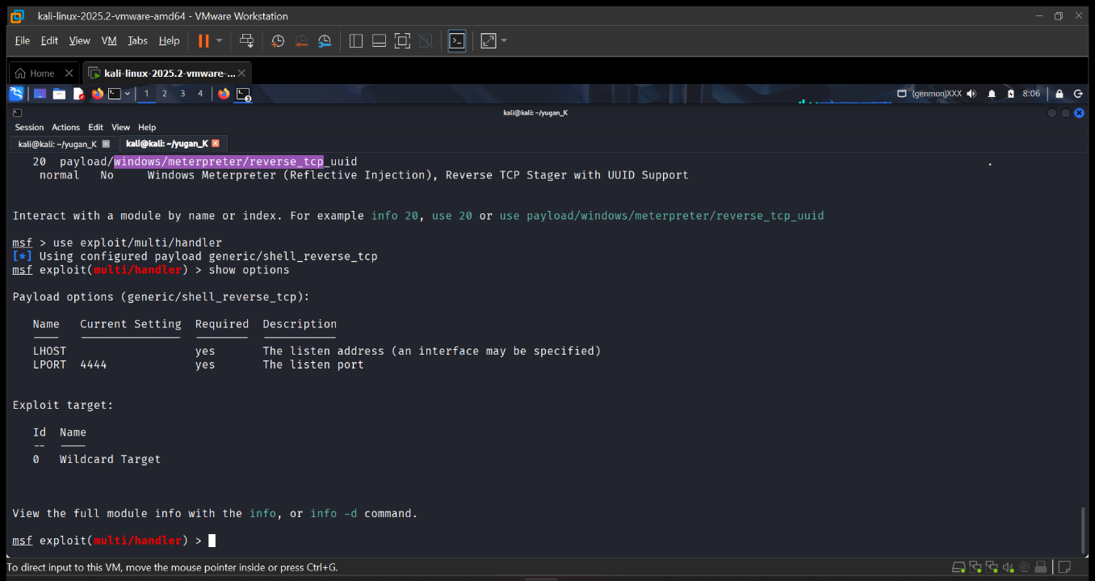

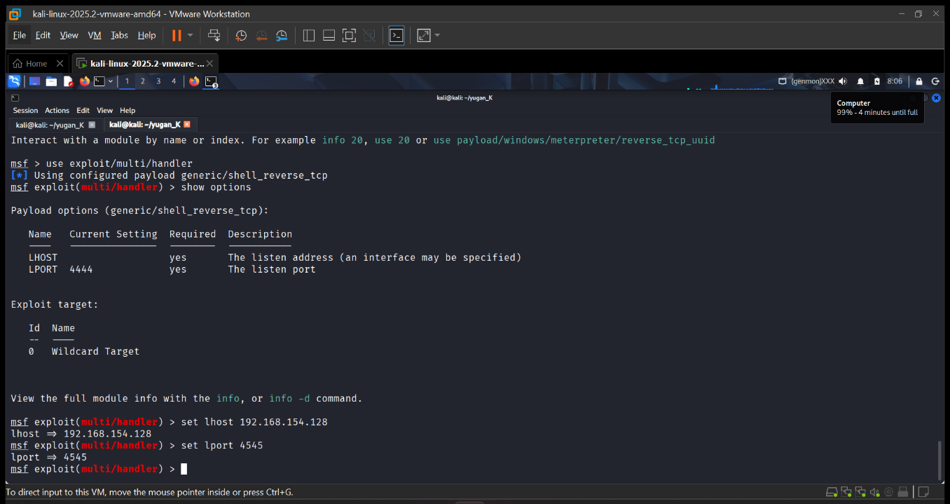

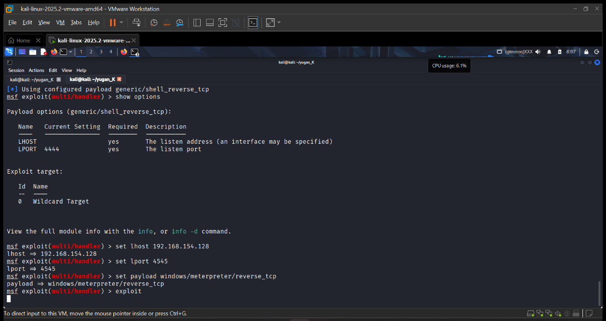
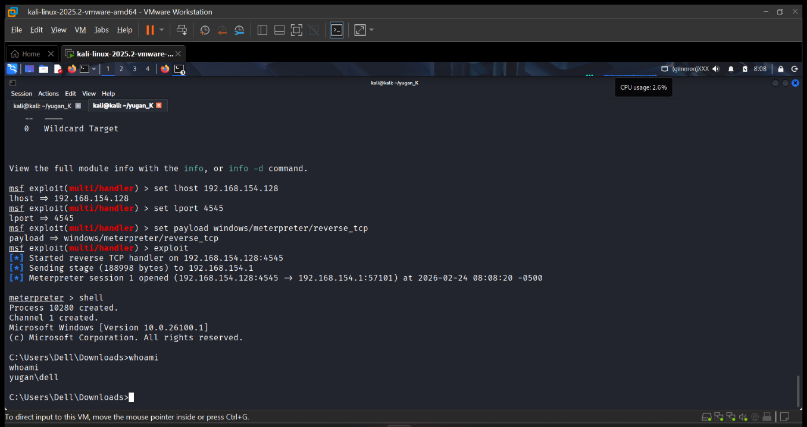

Mitigation Steps
- File Integrity: Verify executables against official hashes/signatures.
- Endpoint Security: Detect and block unauthorized executables.
- Network Defense: Monitor for suspicious reverse TCP connections.
- Patch & Harden: Keep systems updated, disable unused services.
- Application Control: Enforce strict whitelisting of executables.
- User Awareness: Train users against downloading unknown files.
- Incident Response: Isolate compromised hosts, investigate logs, and remediate.

